Case 19-AM,C-Taino-Itiba Cahubaba- Great Bleeding Mother-Silicified sandstone
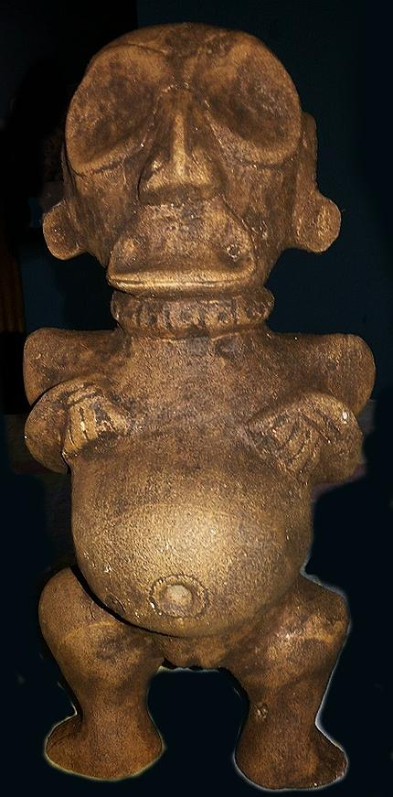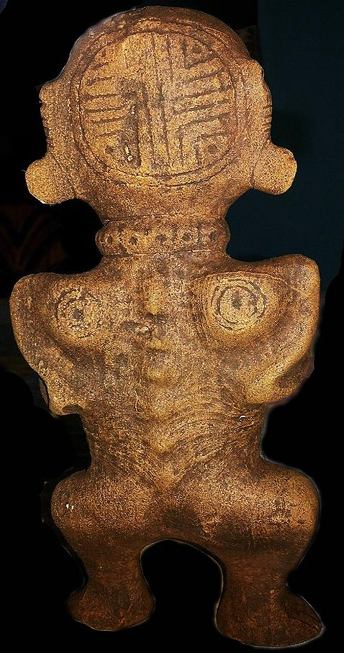

This is an extremely rare and important sculpture of Itiba Cahubaba.
Itiba Cahubaba, “Great Bleeding Mother,” is a primary ancestor spirit among Taino deities called cemís (zemís) and was recorded ca. 1496 by Catalan Spanish Jeronymite Priest Ramón Pané (chapters IX-X) from informants as the first woman to give birth and the ancestress of all humanity,
Itiba Cahubaba dies in childbirth, begetting quadruplets, symbols of the four cardinal points and the four elements: fire, water, air and earth involved in the myth of Yaya and his son Yayael that gave rise to the human species.
Itiba Cahubaba is notable for her eyes, indicative of Taíno depictions of deities. Itiba’s emaciated arms, always folded over her bulging belly, represent the suffering of her creation. Cosmic navigator, Itiba Cahubaba wears a headdress with four trapezoid incisions that appear to depict the Caribbean winter (short) and summer (long) solstices.

First.
This sculpture provides visual representation of the anguish of Itiba Cahubaba in the last stages of pregnancy prior to her fate of dying in childbirth. Her mouth is in a grimace, and her spine is showing through her skin suggesting emaciation.

Second.
This sculpture provides visual representation of the placement of a surgical incision drawn 3-4 inches above her navel prior to the caesarean section that successfully resulted in the delivery of her quadruplets, four male children.

Third.
This sculpture invokes the Tainó world-view as a mixture of black as well as white, capacious enough to hold opposites in tension. Therefore, Tainós invoked opposites as dualities not as dichotomies in their world-view.
They could interpret the number “four” as fertility and as the inverse of fertility. Indeed, Itiba Cahubaba had to die to bring forth life.
In another myth Yayael, the son of Yaya, a mythical cacique, was banished from his home island. He was commanded to seek a new home elsewhere. However, he broke this commandment and returned after 4 months only to be ritually executed by his father for not heeding his father’s sentence of total banishment. Among island people the carrying capacity of the island was of paramount importance to a cacique and the people over whom he was designated to protect, and banishment was one way to address the problem of over-fertility that could outstrip an island’s necessarily limited natural resources and put everyone at risk.
Numerological symbolism is also invoked on the back of Itiba Cahubaba’s head with a “body stamp” that is also found on the bases of frog cemis. The “body stamp” that is on the back of Itiba Cahubaba’s head has four quadrants, and it is suggested that each quadrant represents one of her progeny. Until now this connection of Itiba Cahubaba’s quadruplets has not been connected with the significance of the quadripartite body-stamp symbolism of frog cemis.
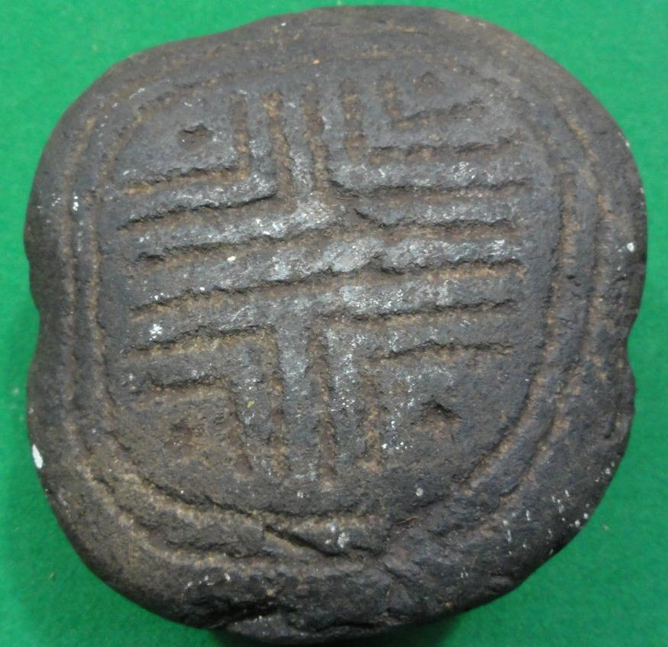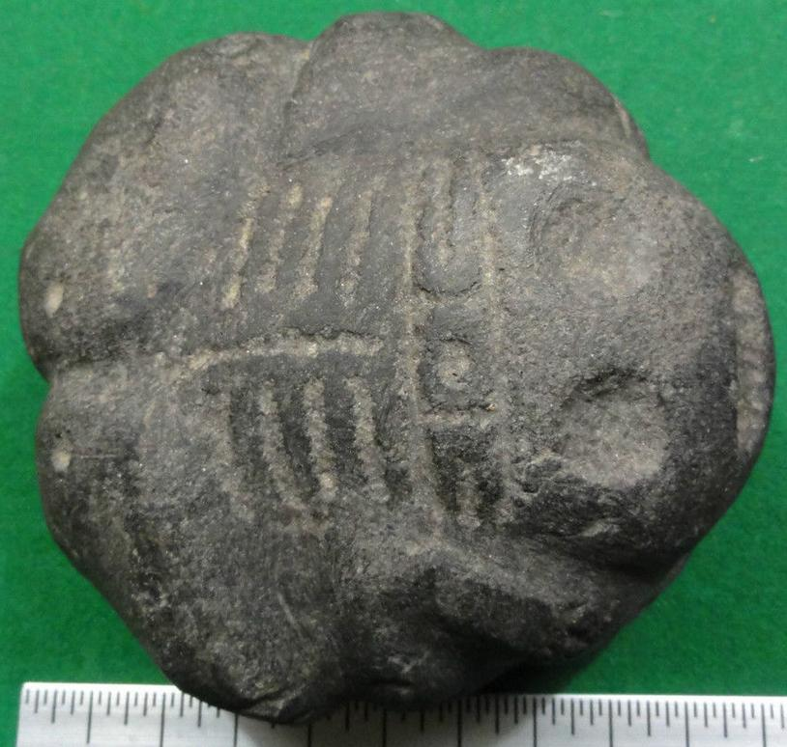
Taino Frog Body-stamp Cemi. Atlantika collection

However, the frog is a well-known Tainó symbol of fertility, and women were thought to become especially fertile when frogs emerged from tadpoles. Here, in this sculpture, we have evidence of the connection between Itiba Cahubaba and frog symbolism. Since the emergence of the frog from tadpoles occurred only once a year, the myth could have the effect of proscribing successful human fertilization to once a year. If this hypothesis is correct, then it is possible that shamans in the instruction of male and female youth’s puberty rites may have given some kind of birth control to both sexes.

This hypothesis is supported by the fact that that shamans gave instruction to pubescent girls in unlocking sexual experience by using puberty rite stones in the shape of circumcised penises to rupture the hymen (Olsen 1974: 348). The exact shape of the puberty rite stone also indicates that it involved the cutting of the foreskin. Therefore, both puberty rites involved uninitiated youth in a spiritually consented, common ritual that was sealed in blood by shamans in the service of the whole community, in order to protect future generations from over-populating their precious, limited insular resources. This spiritual-sexual practice aligned human fertility and its associated liquid component, blood, with the fertility of the land and its liquid component, rain, and the liquid component of rivers and the sea, water, with the fertility of the island’s natural resources.

Fourth, the sculpture of Itiba Cahubaba is the ancestress of humanity indicated by the symbolism of her encircled navel that shows that she is the Taino symbol of life itself. Also her two shoulder blades are similarly inscribed, probably as tattoos, with a center point and two concentric circles, also symbols of life. Perhaps, these concentric circle “tattoos’ were a response to keeping the Tainó free from the Christian devil symbolized by the omnipresent cross.

In Cuba, Itiba Cahubaba is associated with pregnancy, labor, delivery, and—among the people of the eastern mountains—the Virgen de la Caridad del Cobre, the matron saint of the island. Many pregnant and post-natal women attend the Virgen’s shrine in supplication and thanks. Taíno descendants from the Sagua–Baracoa Mountains still make offerings and burn tobacco for the Mother Earth spirit and attribute the success of their crops and the potency of their traditional herbal medicines to her benevolence.¹ The names of Caribbean Taíno cosmological personalities also continue to figure in the toponymy of the islands. There is a historic Río Cahobabo and a nearby village Playitas de Cahobabo in the easternmost part of Cuba. The local population from the region of Cahobabo sustains many Native herbal and culinary traditions.

Olsen,

Russell, Charles T. 1916 [reprinted 2000]. The Divine Plan of the Ages.

